ZRUCC MEMBER FOR THE TERM FROM 01.10.2024 to 30.09.2026
Sl. No. | Under category nominated | Recommendation By Association /Forum. | Recommended Name | Address | Mobile Number | Photo
01 | 10 Members of Parliament have been nominated by Ministry of Parliamentary Affairs on Zonal Railway Users' Consultative Committee | Railway Board | Shri Tejasvi Surya | Hon’ble MP (Lok Sabha),  Bangalore South MP Sri Tejasvi Surya Office, 8, Aurobindo Marg, 5T Block, 1st Phase, J. P. Nagar, Bengaluru, Karnataka 560041 | 9916836964  tejasvi.surya@sansad.nic.in | 
02 |  | Railway Board | Shri E Tukaram | Hon'ble MP (Lok Sabha)  House No. 2346, 14th Ward, Ashoka Colony, Sandur Taluk, Bellary District. | 9448496106  tukarameregar@indialeader.com  e.tukarammp@sansad.nic.in | 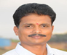
03 |  | Railway Board | Shri C N Manjunath | Hon’ble MP (Lok Sabha),  281, 80 feet main road, Padmanabhanagar, Banashankari IInd stage Bangaluru Karnataka 560070 | 9148745588  9844006699  cnmanjunath.b.rural@gmail.com  drcnmanjunath@gmail.com  drcnmanjunath.mp@sansad.nic.in | 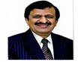
04 |  | Railway Board | Shri M Mallesh Babu | Hon’ble MP (Lok Sabha),  260 Kumbarahalli village Tamaka post Kolar Kolar Karnataka  563103 | 9986039033  9916263939  malleshbabumuniswamy@gmail.com  mallesh1.mbabu@sansad.nic.in | 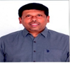
5 |  | Railway Board | Shri B K Parthasarthi | Hon’ble MP (Lok Sabha),  8-61, R Maruvapalli Village Roddam (M) Sri Sathya Sai,, Penukonda, Andhra Pradesh-515123 | 9440678999  9441583456  bkparthasarthi@gmail.com  bk.parthasarathi@sansad.nic.in | 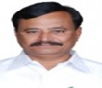
6 |  | Railway Board | Dr. K Sudhakar | Hon’ble MP (Lok Sabha),  347, Peresandra Chikkaballapur Chikkaballapur Karnataka 562104 9845204040 | 9845204040  drsudhakarofficial@gmail.com  keshava.sudhakar@sansad.nic.in | 
7 |  | Railway Board | Km. Priyanka Satish Jarkiholi | Hon’ble MP (Lok Sabha),R.S NO: 290/1 Hill Garden,Anna Road Gokak Belagavi,Karnataka 591307, | priyankajarkiholi2024@gmail.com  priyanka.satish@sansad.nic.in | 
8 |  | Railway Board | Shri Iranna Kadadi | Hon’ble MP (Rajya Sabha),  Allamaprabhu, Kalloli, Taluk-Mudalagi, Dist.- Belagavi-591224. | iranna.kadadi@sansad.nic.in | 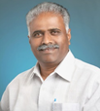
09 |  | Railway Board | Shri Narayana Koragappa | Hon’ble MP (Rajya Sabha),  No. 67, 24th A Cross, Karisandra,Banashankari 2nd Stage, , Bengaluru, Karnataka-560070 | narayana.kbjp@sansad.nic.in | 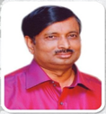
10 |  | Railway Board | Shri Lahar Singh Siroya | Hon’ble  MP (Rajya Sabha),145, 9th Cross 3rd Main HIG Colony, RMV Extension 2nd Stage, Bangalore-N.B.M.P (North), Karnataka 560094 Tel.- | laharsingh.siroya@sansad.nic.in | 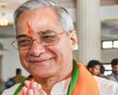
11 | GOA State Legislature representative | Joint Secretary Legislature | Shri Nilesh Cabral | H.No.2281/A, Flat No. TF-3, Ramalayam Building, Guardian Angel church Road, Bepquegal Curchorem-Goa, Pin:403706 | 9822103292 mla.curchorem.gvs@gov.in nileshcabral@rocketmail.com | 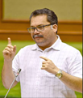
12 | Andhra State State Legislature representative | Secretary-General to the State Legislature Govt. of Andhra Pradesh | Hon'ble MLA Shri.Aranii Srenevasulu (JMC) | Aranii Srenevasulu (Jmc), M.L.A  Door No. 24-19, lakshmi Nagar Colony, Kongareddypalli, Chittoor, Chittoor District,  Andhra Pradesh-517001 | 98405 67777  mlatirupati@gmail.com | 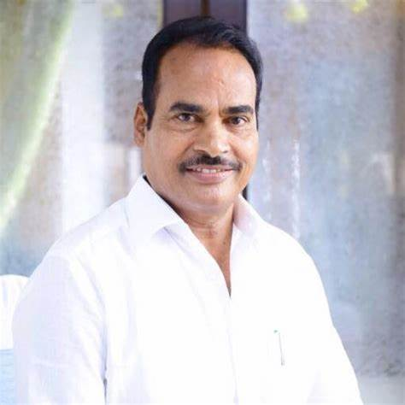
13 | Andhra Pradesh  State representative of Agricultural linterest | Principal Secretary to Govt.of Andhrapradesh | Shri.K.Sreenivasulu, | Dy.Director of Horticulture Fruits, Office of Director Horticulture & Sericulture  Guntur,Andhra Pradesh-522004. | 7330745555 | Decalartion not recieved
14 | Andhra Pradesh  State representative official of State Govt. | Principal Secretary to Govt.of Andhrapradesh | Shri V Raja Gopal | Executive Engineer,  Roads & Buildings Division, Anantapur  opp. Government Medical College, Sainagar,  ANANTHAPURAMU- 515002 | Mb.No. 9440818080,  eeroadsanantapur@gmail.com | Decalartion not recieved
15 | Tamil Nadu State Legislature representative | Additional Chief Secretary to government of Tamil Nadu, Chennai, Tamil Nadu State | Shri Thiru D. Mathiazhagan | M.L.A Bargur Constituency,  58-B, Gandhi Nagar Basheer  Mohammed Lay out  Krishnagiri-635001 | 9842744190
16 | Chamber of Commerce & Trade Associations | Federation of Karnataka Chambers of Commerce and Industry,  Federation house, Kempegouda Road Bengaluru 560009 | Shri M G Balakrishna, | President FKCCI, Federation House,  Kempegowda Road,  Bangalore-560009, | 9844700003  president@fkcci.in | 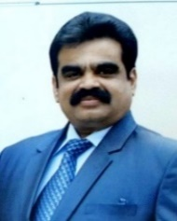
17 | Chamber of Commerce & Trade Associations | Karnataka Chamber of Commerce and Industry, Hubballi. | Shri Shiddramayya P. Saunshimath | President, Karnataka Chamber of Commerce & Industry  M/s. Gadag Tea Depot,  Tea dealers.  Grain Market, Gadag- 582101 | 9916209696  office@kccihubballi.org  kccihble@gmail.com | 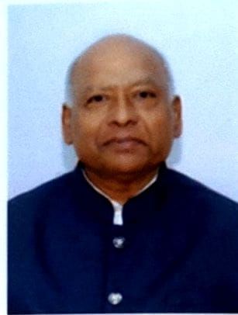
18 | Chamber of Commerce & Trade Associations | Mysore Chamber of Commerce and Industry, Mysuru, | Shri K B Lingaraju | President, Mysore Chamber of Commerce & Industry  #54, D. Devaraja Urs Road, Mysuru-570001 | 9980560530  9606850246  mccimysore@gmail.com | 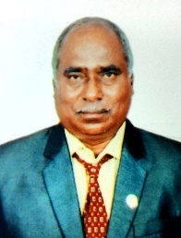
19 | Chamber of Commerce & Trade Associations | Karnataka Sponge Iron Manufacturers Association®, Ballari | Shri Srinivas Murthy P | # 149, 3rd Cross, 5th Block, Banashankari 3rd Stage, Bangalore- 560085 | 9880788843  Srini243@gmail.com | 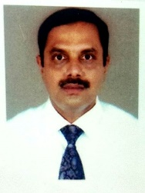
20 | Chamber of Commerce & Trade Associations | Jindal Steel Works, Toranagallu | Shri Sushil Nowal | Executive Vice president,  JSW Steel LTD.  Vijayanagar Works, Ballari. 583275 | 9448286056  8395249242  Sushil.nowal@jsw.in | 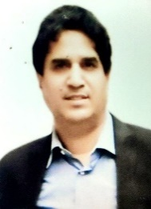
21 | Public Sector Undertaking including Ports | Marmugoa Port Trust, Goa | CAPT. Himanshu Shekar | Mormugao Port Authority,  General Administrative office,  Headland sada.  Mormugao-403804 | 8097715412  tm@mptgoa.gov.in | 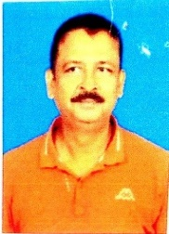
22 | Public Sector Undertaking including Ports | CONCOR, Bangalor | Declaration Not received
23 | Registered Passenger Association | Gadag District Railway User Association, Gadag | Shri G.K.Adappagoudar | Adyapak Nagar, Hulkoti-582205  Tq/Dist: Gadag,  Karnataka State | 9448119055  8372289055  gkagoudar@gmail.com | 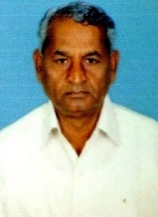
24 | Registered Passenger Association | Vijayanagar Rail Passengers & Telecom Users Association, Hospet | Shri Babulal G Jain, | Babulal Jain & Co, Arihant complex, Hampi Road, Hosapete- 583201 | 9448358112  bjcpal@gmail.com | 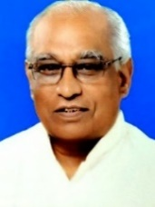
25 | Consumer Protection Organisation | Sanvordem - Curchorem Rail Consumers Association, Goa | Shri Devanand S. Naik Bhandari. | House No. 762, Kamral Curchorem Goa-403706 | 9923697709  devanandnaikbhandari1960@gmail.com | 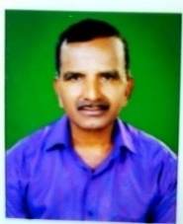
26 | Handicapped Association | Margadarshi the Association for physically Challenged, Bengaluru | Declaration Not received
27 | Nominee of General Manager | General Manager | Mahendra H. Singhi | Singhi Associates,  1st floor, Samyukta Karnataka Building, Koppikar Road, Hubballi-580020. | 9448142151  mahendrasinghi@hotmail.com | 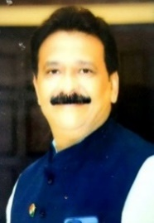
28 | Nominee from Union Minister Lok Sabha | Shri. H.D. Kumaraswamy, Hon'ble Minister of Heavy industries and Steel Government of India | Shri Basavaraju K.M | S/o. S. Marigowda,  KL-132, 3rd Cross, Marigowda Layout, Mandya City, Mandya Karnataka 571401 | 9448642595  kyamsovbraj@2562.com | 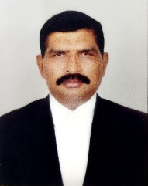
29 | Nominee from Union minister Rajya Sabha | Smt. Nirmala Sitharaman, Minister of finance and Corporate Affairs, Government of India, New Delhi-110001, | Shri Dr. Laxman H | Sri Balaji Hospital, LMD Towers, Near Shanthi Layout Bus stop, Rama Murthy Nagar, Bangalore :-560016 | 9880795495 | 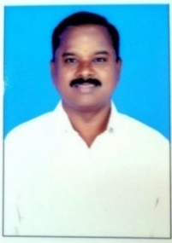
30 | Tamil Nadu State Government Representative(Official) | Additional Chief Secretary to Government of Tamil Nadu, Chennai, Tamil Nadu State. |  | Additional Chief Secretary to Government, Transport Department, Channai-600009 | 04425671475  tranusop@tn.gov.in
31 | Tamil Nadu State Agricultural Interest | Agricultural production Commissioner and principal secretary of Tamil Nadu Chennai-9 | Thiru C.Muthu Kumar, | No.3/682,  Venkatasamudram Village, Pappireddipatti Taluk, Dharmapuri District, Tamil Nadu- 636905 | 9445696518  9345795955  chimuthu@gmail.com | 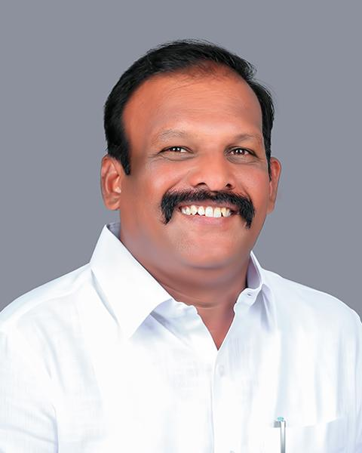
32 | Special Interest Railway Board | Railway Board | Shri Keshava Ramachandrappa, | R/O Mandibela Villaga & P.O Devanahalli Tq, bengaluru Rural District 562110 | 9449730778  r.keshoov12@gmail.com | 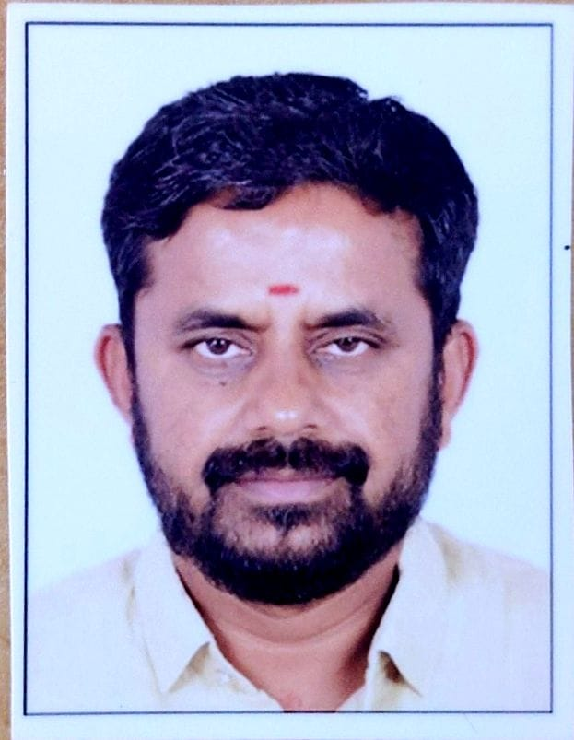
33 | Special Interest Railway Board | Railway Board | Shri K Madhan | R/o.Door No.6, Vasavi Nagar, 1st main Road 13th Cross, Ward no.38 (Dinnur Back Side) Hosur 635109 Krishnagiri District. | 9443245594  9791590956  madhandmk122@gmai.com | 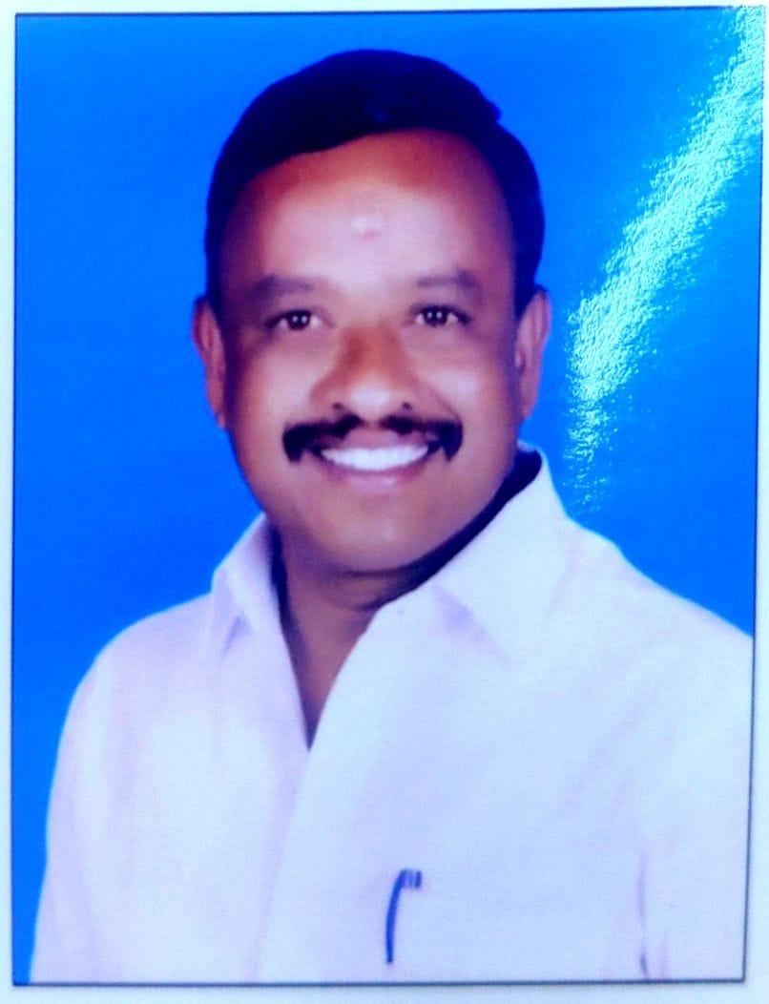
34 | Special Interest Railway Board | Railway Board | Shri Vishwanath Patil | H.No. 17, Aghyapak Nagar, Hubballi, 580032, Mob. 9845179463 | 9845179463  Vspatil463@gmail.com | 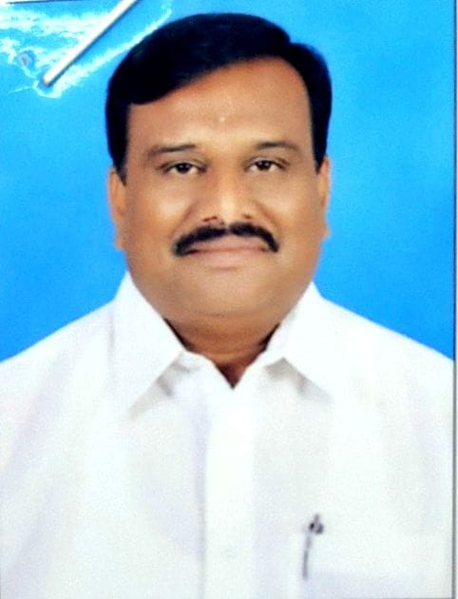
35 | Special Interest Railway Board | Railway Board | Shri Raghavenddhiraa | 16-50 Feet Cross Road, Ganesh Temple Streeet, Girinagr, Bangalore south, Bengluru, Bansankhari III Stage, Kanataka, 560085 | 8368375166  raaghraagh@gmail.com | 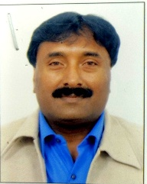
36 | Special Interest Railway Board | Railway Board | Shri M Y Rudresh | R/o "Susheela" 1st B Cross Tank Road, Maruthi Nagar, Tumakuru, Karnataka | Declaration-Form not received
37 | Special Interest Railway Board | Railway Board | Shri Mallikarjun Santhanakrishnan | R/o Survey No. 28 & 29, Soukya Road, Bengaluru, Karnataka, 560067 | 9845499929  ask@gsglobal.in | 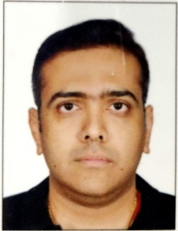
38 | Special Interest Railway Board | Railway Board | Shri Raviraja Sagar. | U, H. No. 09, “Karnavati”, Ranakpur Layout, Bengeri, Hubballi Karnataka-580023, | 9449355091  ravirajasagar@gmail.com | 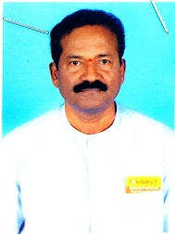
39 | Special Interest Railway Board | Railway Board | Shri Bhargav R. | #26, 1 st Floor, SST Street, V V Puram, Bengaluru, Karnataka 560004, | Mob. 9972443333  Declaration-Form not received | 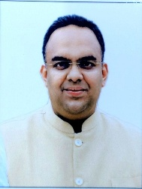
40 | Special Interest Railway Board | Railway Board | Shri Vilas Rama Gauns Dessai | House No. 223, Near Primary School, Devonamal, Kalay, sanguem, South Goa, 403704 | Mob. 9623122038 | 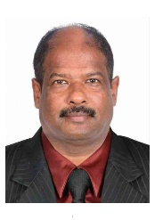
41 | Special Interest Railway Board | Railway Board | Shri B. N. Lakshmipathi | B.N.L. Brick Industries, Bijawar, Hindupur Road, madhugiri, Tumkur Dist.,572132 | Mob. 9341239281  Bnlakshmipathi36@gmail.com | 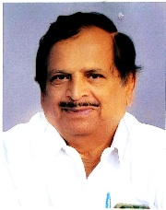
42 | Special Interest Railway Board | Railway Board | Shri.R.C.Anjinappa,  S/o Late Shri.Chikkanna, | Rajavanthi Posy,Pavagada Taluk,Tumkur District.,561202 | Mob. 9986378878 | 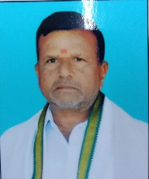
43 | Special Interest Railway Board | Railway Board | Shri Gurusiddesh Kotambri (Ashwin), | Milan agencies,  Dealers for: Hindustan petroleum Corp. Ltd.,  T. B. Dam Road, Hospete,  Dist. Vijayanagara-583201. | Mob. 9448359404 | Decalaration not received
44 | Special Interest Railway Board |  | Shri.Kranthi Raju S,  S/O Shri.S.P Suresh Kumar, | #48/2 5th cross,Maruthi Nagara,  Bengaluru-560072 | Mb.No.9845052036,  9342399988 | 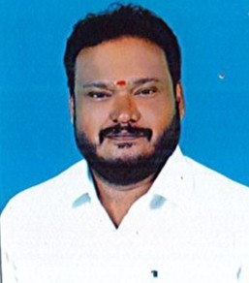
45 |  |  | Shri.Pramod Gopalrao Joshi, | H.No.194/B, Killa Gokak, 591307, Dist.Belagavi, Karnataka, | Mb.No.9481005405. | Decalaration not received
46 |  |  | Shri.Chidanand Veerappa Demshetty, | Plot No.27, Bhagya 171 E, Aditya Nagar, Gokak, Karnataka-591307, | Mb.No.944888128. | Decalaration not received
47 |  |  | Shri.Gurupad Basappa Kalli, | Post:Hosur,Tq:Soudatti, Dist.Belagavi, Karnataka, | Mb.No.997261332. | Decalaration not received
48 |  |  | Shri.Iranna Yallappa Chandargi, | Itnal Near Hanamanth Devar Temple, Post:Sattigeri,Tq:Yaragatti, Dist.Belagavi-591129, | Mb.No.9980624793 | Decalaration not received
49 | Elected from DRUCC/SBC to ZRUCC | Secretary & Sr. DCM DRUCC/SBC | Shri G. Venu, | 18, Doddabommasandra, Vidyaranyapuram, Yelahanka, Bengaluru, Karnataka-560097 | Mob. 9986969998  venuyadav1966@gmail.com | 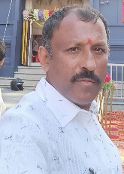
50 | Elected from DRUCC/MYS to ZRUCC | Secretary & Sr. DCM DRUCC/MYS | Shri D. H. Vijay Kumar, | S/o Shri D. M Hanamanthaiah,  C/o M jayanna, Lakshmamma Layout, Huliyar Road, Taluk and Post Chitradurga  Dist:-577598 | Mob. 9972093498 | 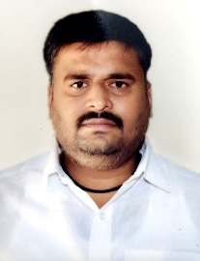
51 | Elected from DRUCC/UBL to ZRUCC | Secretary & Sr. DCM DRUCC/UBL | Shri Ravindra S Baligar, | Baligar Autos, 14 Akalwadi complex, Vidyanagar, Hubballi-580021 | Mob. 9482165400  office@kccihubballi.org  kccihble@gmail.com | 